**Architecture**

**MVC Pattern**

Model view controller (MVC) is a very useful and popular design pattern.

In a typical application, you will find these three fundamental parts:

* Data (Model)
* An interface to view and modify the data (View)
* Operations that can be performed on the data (Controller)

The MVC pattern, is this:

1. The model represents the data. The model does NOT depend on the controller or the view.
2. The view displays the model data, and sends user actions (e.g. button clicks) to the controller.
3. The controller provides model data to the view, and interprets user actions such as button clicks. The controller depends on the view and the model.

**Advantages:**

**Re-usability**- MVC makes model classes reusable without modification.

MVC can also make the *view* reusable without modification.

**Separation of concerns** - view and backend can be developed parallel without much dependency.

**TDD support**- Test driven development is possible as unit test cases can be wriiten on model objects.

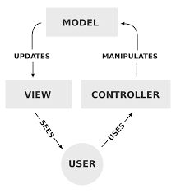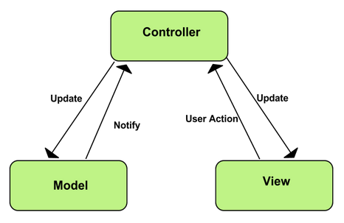

(images add any one)

1st one from Wikipedia

**Technology**

Initially, we opted for Fiori along with SAP HANA technologies. But, during the Hi-Fi prototyping we came across the limitation and restrictions from the framework. On further analysis, we figured that it is not suitable to meet our project requirements.

We have decided to go with following two options of technology choices

**Option 1:**

**Firebase with Angular js:**

* Firebase is not a traditional database. It's a complete real-time, scalable backend. It provides all the tools needed to build rich, collaborative applications using only client-side code.
* Angular JS is a structural framework for creating dynamic web applications by extending HTML capabilities
* Features like data binding and dependency injection makes it easier to develop apps with less code
* AngularFire is the officially supported AngularJS binding for Firebase

**Advantages**

* Creating a web application without having to worry about the back-end side
* Firebase makes it possible to sync data in real time with our application without bothering about the back-end, by just making some API Calls
* Combining the power of AngularJS two-way data binding with Firebase results in a three-way synchronization
* Apps can consist of only client-side code, relying 100% on Firebase's backend, or Firebase can communicate with custom server-side code
* It can easily fit in at any stage of development.

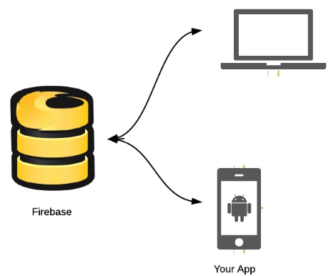

**Option 2:**

**ASP .NET MVC5:**

ASP.NET MVC gives you a powerful, patterns-based way to build dynamic websites that enables a clean separation of concerns and that gives you full control over markup for agile development. ASP.NET MVC includes many features that enable fast, TDD-friendly development for creating applications that use the latest web standards.

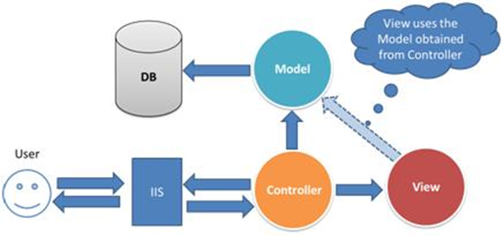

The comparison of the versions of ASP .NET MVC:

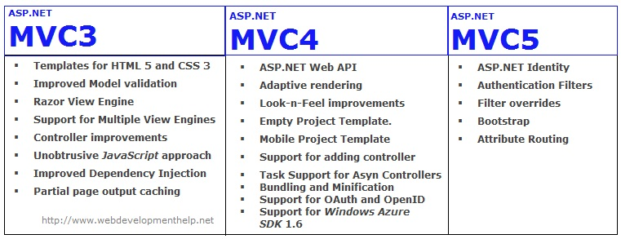

Advantages:

* Enables the full control over the rendered HTML.
* Provides clean separation of concerns(SoC).
* Enables Test Driven Development (TDD).
* Easy integration with JavaScript frameworks.
* Following the design of stateless nature of the web.
* RESTful urls that enables SEO.
* No ViewState and PostBack events